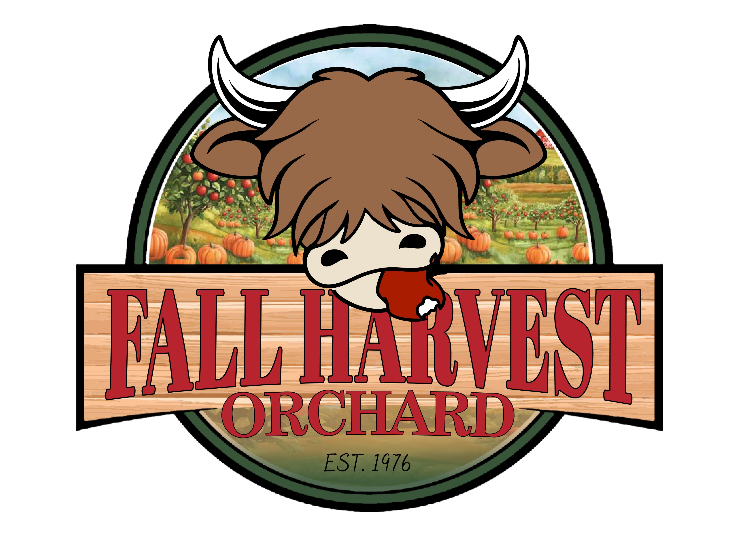
School Reservation Request Form
2026

Wagon Ride Package (Includes wagon ride, apple and gourd)
Students (Minimum of 25 students) - $12/each
Teachers/Chaperones - Free
Includes:
- Wagon ride with educational talk (Our goal is to prioritize seating on wagon rides to students and adequate numbers of teachers/chaperones)
- Apple and gourd for each student will be sent with teacher(s) at end of visit
- Free play time
  - Access to all ticketed activities open on weekdays (giant corn bin, red train, farm ropes, jump pillows and more)
  - Access to all free activities open on weekdays (visit/feed animals, hay bale mountain, tire climb, playground structures and more)
- Staff and supervisors are asked to monitor students at all times
- Groups welcome to bring snacks/sack lunches

Teacher-Guided Package
Students (Minimum of 10 students) - $10/each
Teachers/Chaperones – Free
Includes:
- Informational guide sheet given to teacher(s)
- Free play time
  - Access to all ticketed activities open on weekdays (giant corn bin, red train, farm ropes, jump pillows and more)
  - Access to all free activities open on weekdays (visit/feed animals, hay bale mountain, tire climb, playground structures and more)
- Staff and supervisors are asked to monitor students at all times
- Groups welcome to bring snacks/sack lunches

**Group reservations will be billed as one unit and all materials will be sent with Coordinator to distribute at their discretion

Reservations
Please submit completed request form in person during Fall Harvest Orchard open hours or email us at fallharvestorchard@gmail.com. We will contact you shortly after submission to confirm your reservation or offer alternatives if your request is not available.

Contact Information:
School Name: _______________________
Contact: ____________________________
Email: ______________________________
Phone: _____________________________
Billing request: Card Cash Invoice

Field Trip Info:
Number of Students: __________________
Number of Teachers/Adult Helpers: ______
Age/Grade of Students: _______________
Packages: Wagon Ride
Teacher Guided
Will group be eating lunch on site? _____

Optional add-ons
Educational Coloring book for each student (Ages PreK – 2nd) -additional $2/student
Pie pumpkin instead of gourd for each student - additional $2/student
Gem mining - additional $7/student

Requested Dates and time:
Reservations are on a first come first served basis and are by reservation only. They are offered on Thursdays and Friday of our season (with the exception of MEA Thursday and Friday).

Primary Date______________________ Secondary Date _________________________
Start Time 9:30am 10.00am 10:30am 11:00am 11:30am
12:00pm 12:30pm 1:00pm 1:30 pm Other _________

- What if it rains? If we feel it is safe to remain open, we will resume as normal with reservations. If the rain becomes too heavy and we have to suspend activities – we will make every effort to reschedule
- The designated contact will receive a courtesy email confirming your reservation and final head count in the beginning of your reservation week.
- Cancelling reservations – Reservations can be cancelled or rescheduled to an open day. Please notify us as soon as possible with changes.

Thanks for choosing
Fall Harvest Orchard for your field trip!

